Making an LED Blink using Analogue Input
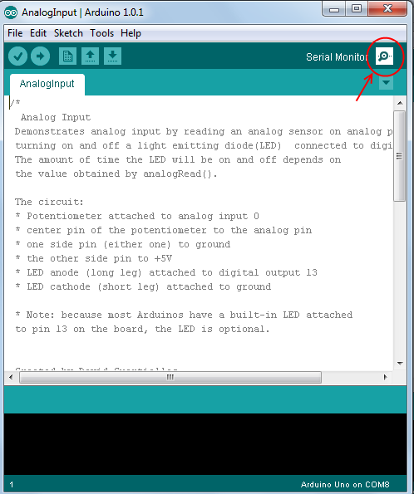
- Create the circuit shown on last page
- Open the Arduino IDE program on your computer
- In the menu at the top of the arduino program go to
File → Examples → 03.Analog → AnalogInput
- Change the code to look like the program code below, make sure you also copy the semi-colons ';'
- Upload the code to your arduino
- Open up the serial monitor (see picture to right)
- Make sure that the bottom right box in the Serial Monitor is set to 9600 baud
- Cover up the light sensor, you should see the values change, but it doesn't change enough for the LED to turn on.
- Change the code so that the LED turns on when you cover up the light sensor. For more hints on how to change the if statement see the previous worksheet.
Extensions

- Change the code so when you half cover up the light sensor the LED blinks.

Program Code (File → Examples → 03.Analog → AnalogInput)
int sensorPin = A0; // select the input pin for the potentiometer
int ledPin = 13; // select the pin for the LED
int sensorValue = 0; // variable to store the value coming from the sensor
This line tells the arduino that we want to send text to the computer, without it Serial.println() wouldn't do anything
void setup() {
// declare the ledPin as an OUTPUT:
pinMode(ledPin, OUTPUT);
Serial.begin(9600);
}

void loop() {
// read the value from the sensor:
This line allows you to send text to our computer and it will be displayed in the Serial Monitor. Here we are sending the value contained in the variable 'sensorValue'.
sensorValue = analogRead(sensorPin);
Serial.println(sensorValue)
if(sensorValue > 1000){
// turn the ledPin on
digitalWrite(ledPin, HIGH);
}else{
// turn the ledPin off:
digitalWrite(ledPin, LOW);
}
delay(100);
}
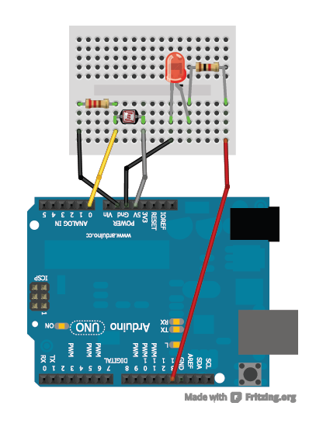
Circuit Diagram
1K ohm Resistor
10K ohm Resistor
Light Sensor

